12 October 2017
[28-17]

Abandonment Report – Proposal P1034

Chemical Migration from Packaging into Food

Food Standards Australia New Zealand (FSANZ) prepared a proposal to assess the public health and safety risk of chemicals which may migrate from packaging materials into food, and to identify and manage any risks.

Under section 72 of the Food Standards Australia New Zealand Act 1991 (the FSANZ Act), FSANZ sought submissions to a Consultation Paper on 12 November 2014 and received 37 submissions. FSANZ sought further submissions on the assessment on 10 June 2016 and received 18 submissions.

Pursuant to paragraph 60(b) of the FSANZ Act, FSANZ decided to abandon the Proposal. Information on the reasons for this decision is contained in this Report.

Information about rights for a review of this decision is provided in this report and in Part 6 of the FSANZ Act.

Table of contents

Executive summary 2
1 Introduction 4
1.1 The Proposal 4
1.2 Current standards 4
1.3 Reasons for preparing the Proposal 5
1.4 Procedure for assessment 5
1.5 Decision 5
2 Summary of the assessment 5
2.1 Summary of issues raised in submissions 5
2.2 Risk assessment 6
2.2.1 Overview 6
2.2.2 Initial risk assessment 7
2.2.3 Updated risk assessment 8
2.2.4 Conclusions 8
2.3 Risk management 8
2.3.1 General approach to risk management 8
2.3.2 Determination of residual risk 9
2.3.3 Risk management options: graduated approach 10
2.3.4 Non-regulatory risk management - the food packaging information guide 11
2.3.5 Conclusion 12
2.4 Risk communication 13
2.4.1 Consultation 13
2.4.2 Communication strategy 13
2.5 FSANZ Act assessment requirements 13
2.5.1 Section 59 13
2.5.2 Subsection 18(1) 14
2.5.3 Subsection 18(2) considerations 15
3 Rights of review 15

Supporting documents

The following documents which informed the assessment of this Proposal are available on the FSANZ website at http://www.foodstandards.gov.au/code/proposals/Pages/P1034ChemicalMigrationfromPackagingintoFood.aspx

Supporting Document 1 Summary of Submissions

Supporting Document 2 Issues raised during public consultation

Supporting Document 3 Risk assessment

Executive summary
Proposal P1034 was prepared to assess the public health and safety risks of chemical migration from packaging into food (CMPF), and to and manage any identified risks. This paper summarises the results of that assessment, including analytical survey results on food packaging chemicals.

Following that assessment and further public consultation, FSANZ decided to abandon Proposal P1034. This paper explains the reasons for that decision and outlines future action by FSANZ in relation to CMPF.

FSANZ assessed the risks associated with migration of packaging chemicals and analysed control measures used in the packaging supply chain to mitigate CMPF. Details were provided in FSANZ’s Call for Submissions report of June 2016.

A risk assessment based on an analysis of a database of over 1300 food contact substances found that exposures to most chemicals used to produce food packaging are low and unlikely to pose a public health and safety concern. This conclusion was supported by a number of analytical surveys investigating the presence of packaging chemicals in Australian and New Zealand foods.

However, a screening study identified a need for more comprehensive analytical data for two phthalate compounds, di(2-ethylhexyl) phthalate (DEHP) and diisononyl phthalate (DINP), to enable a more robust assessment of any potential health and safety risks. As a result a comprehensive survey was undertaken investigating the levels of DEHP and DINP and five additional plasticisers in a wide range of Australian foods. Results from this more detailed survey found that estimated dietary exposures are below the tolerable daily intakes (TDIs) for these substances and do not pose a public health concern.

FSANZ also recently completed a survey investigating the migration of mineral oil hydrocarbons (MOH) from paperboard packaging into Australian foods. The survey indicated that the levels of MOH from food packaging in Australian foods are very low and unlikely to be of public health concern. An additional survey of packaging chemicals including phthalates, printing inks and photoinitiators in New Zealand foods also found that estimated dietary exposures to these chemicals are low and not of concern for human health.

FSANZ consulted widely with a broad range of stakeholders, and overall, concluded that sufficient control measures are in place to control CMPF. However, some food businesses showed poor awareness of CMPF and knowledge of suitable control measures. This appeared to be more evident for small-to-medium enterprises (SMEs).

A range of risk management options were proposed. FSANZ’s assessment was that a graduated risk management approach offered the most advantages in terms of protection of public health and safety and cost effectiveness. The graduated approach served to address chemicals with different risk profiles, concerns with clarity about current requirements, and gaps in the awareness of CMPF.

To improve awareness and knowledge about CMPF, FSANZ plans to develop a food packaging information guide to provide a consolidated and comprehensive source of information for industry, address the gaps in awareness and knowledge for SMEs, provide general information on safety issues with CMPF for consumers, and describe the obligations on food businesses (particularly SMEs) to use safe packaging materials.

1 Introduction

1.1 The Proposal
Proposal P1034 was prepared to assess whether additional measures are required to manage food safety risks arising from chemical migration from packaging into food (CMPF) in Australia and New Zealand.

FSANZ has been investigating the potential public health and safety risks associated with chemicals in food packaging for a number of years.

In 2007, in response to stakeholder concerns about contaminants [e.g. bisphenol A (BPA), phthalates and printing inks] leaching from packaging into food, FSANZ initiated a preliminary review of the current regulatory framework for food packaging materials. Based on the findings of this work, Proposal P1034 was prepared in 2014. The aim of this work was to build on FSANZ’s understanding of the nature and possible risks from CMPF, to ascertain the extent to which risks are managed by industry and to assess whether further requirements are needed.

Additional information summarising the chronology of FSANZ’s work on CMPF is listed in Attachment 1.

Details of the Proposal’s objectives, scope, and methodology were outlined in the November 2014 Consultation Paper and summarised in the June 2016 Call for Submissions that are available on the FSANZ website.

1.2 Current standards
Food safety risks from CMPF are managed primarily through the Food Acts of New Zealand and the Australian States and Territories. These Acts make it an offence to sell food packaging or handling materials that are unsafe or will make the food unsafe.

The Australian New Zealand Food Standards Code (the Code) contains various requirements which apply to food businesses and to food for sale. The Food Acts also make it an offence to contravene these requirements.

The Code’s requirements relating to food packaging requirements pertinent to both Australia and New Zealand include the general packaging requirements in Standard 1.1.1 (subsections1.1.1—10(10) and (11) (Packaging requirements) and maximum levels (MLs) for three packaging contaminants, regulated by subsection 1.1.1—10(5) and Standard 1.4.1. Details of maximum levels for specific foods are provided in Schedule 19 (sections S19—4 (metal contaminants) and S19—5 (non-metal contaminants). Standard 2.6.2 has requirements for chemical limits in packaged water which align with World Health Organization drinking water guidelines (WHO, 2011).

For Australia, Standard 3.2.2 and Standard 4.2.1 have requirements pertaining to food packaging. Standard 3.2.2 contains requirements for food businesses (including manufacturers, caterers, importers and retailers) regarding the safety of packaging. Standard 4.2.1 also contains requirements for seafood businesses regarding the safety of packaging.

The relevant provisions of the Food Acts and of the Code are detailed in the Supporting Documents 1 and 2 released with the November 2014 Consultation Paper. These are available on the FSANZ website.

1.3 Reasons for preparing the Proposal
The Proposal was prepared to determine whether there are any public health and safety concerns from the migration of chemicals from virgin and recycled packaging into food and whether additional measures are required for their management.

1.4 Procedure for assessment
The Proposal was assessed under the Major Procedure set out in Division 2 of Part 3 of the Food Standards Australia New Zealand Act 1991 (the FSANZ Act). The Proposal involved two rounds of public consultation – the November 2014 Consultation Paper and the June 2016 Call for Submissions.

1.5 Decision
The Proposal was abandoned under paragraph 60(b) of the FSANZ Act.

2 Summary of the assessment

2.1 Summary of issues raised in submissions
Consultation with a range of industry, government and consumer stakeholders (through meetings, surveys and responses to the consultation papers) guided FSANZ in its considerations for P1034.

Preliminary consultations were undertaken with an Industry Advisory Group comprising peak bodies, packaging industry members and large manufacturers/brand owners. FSANZ subsequently established a Packaging Advisory Group (PAG) which had broader stakeholder representation, including smaller industry members, a consumer representative and jurisdictions.

Section 73 of the FSANZ Act requires FSANZ to have regard to all submissions made in response to a Call for Submission during the submission period when making a decision whether to prepare a Standard or a variation to a Standard; or to abandon the Proposal. FSANZ received 18 submissions in response to the 2016 Call for Submissions. These submissions came from both industry and state/territory government departments.

FSANZ has had regard to and analysed all submissions received in response to the November 2014 Consultation Paper and to 2016 Call for Submissions. A summary is provided at Supporting Document 1 and a detailed overview of the views of all submitters from the 2nd Call for Submissions Report is in Supporting Document 2.

During consultation, FSANZ put specific questions to stakeholders to better understand issues relating to CMPF, including the range of measures used by different industry sectors to control CMPF and the effects of various risk management options on stakeholders.

FSANZ concluded that a prescriptive approach in Australia and New Zealand to manage CMPF was unnecessary and most submitters supported a graduated approach.

The public consultations provided insight into industry areas that have gaps in the awareness of control measures for CMPF, particularly in SMEs. This was also corroborated by submissions to the November 2014 consultation paper.

To help focus engagement with SMEs, a targeted survey for SMEs was prepared. Businesses were approached through a range of means (peak bodies, government contacts and Board members).

The overall conclusion obtained from these consultations was that there is a broad range of knowledge amongst SMEs about CMPF and most companies’ surveyed show some level of awareness and have basic control measures in place (e.g. HACCP).

Most businesses stated the importance of (and reliance upon) supply chain assurance and having trusted suppliers but most SMEs would appreciate more guidance on identifying risks from CMPF and determining how they can be managed.

FSANZ was encouraged to adhere to the principles of best practice regulation, and if any new regulations in Australia and New Zealand were introduced there had to be robust scientific evidence that a risk from CMPF existed, otherwise this would impose unnecessary costs for industry. There was a suggestion for FSANZ to consider a tiered approach based on risk which may involve combinations of regulatory and non-regulatory measures.

Consumers raised concerns with FSANZ that the current general requirements for food packaging to be safe may not be enough to safeguard consumers. They proposed that FSANZ should take a precautionary and a more prescriptive approach similar to the requirements in Europe and the US.

Some submitters criticized FSANZ for narrowing the scope of the Proposal to exclude other packaging materials such as nanomaterials and smart packaging.

Therefore, taking into account the submissions and in order for FSANZ to continue with Proposal P1034 the following work was progressed:

- risk analysis work to identify any uncontrolled hazards and build on the evidence base following the 24th ATDS outcomes and undertake a dedicated packaging follow up chemical survey (the phthalate survey) (see 2.2)
- industry follow-up and consultations with SMEs (food service sector, discount shops, quick service restaurants)
- consult with jurisdictions through the Implementation Subcommittee for Food Regulation (ISFR) to discuss their views on risks from CMPF and possible practical risk management options which could be adopted through the Food Acts
- consider appropriate risk management options (see 2.3) by taking account of the risk assessment findings together with consultations and discussions with stakeholders.

2.2 Risk assessment

2.2.1 Overview
To gain an understanding of the overall risk posed by CMPF, FSANZ investigated information on the hazard characteristics of chemicals used to produce food packaging and estimated dietary exposure to these chemicals due to migration into food. A wide range of information sources was used for this work, in particular USFDA and EFSA databases and publications, and data from analytical surveys of packaging chemicals in Australian foods.

FSANZ’s scientific assessment indicated that most chemicals used to produce food packaging are unlikely to pose a public health concern. This is predominantly due to the low dietary exposure expected for the majority of these chemicals (see June 2016 Call for Submissions, Supporting Document 3).

A summary of FSANZ’s initial risk assessment, detailed in the June 2016 Call for Submissions, is provided in section 2.2.2.

Since publication of the 2016 Call for Submissions the findings of three additional surveys have been finalised and become available. These are:

- a FSANZ survey of plasticisers in foods

- a FSANZ investigation into the migration of mineral oil hydrocarbons (MOH) from paperboard packaging into foods

- a survey of packaging chemicals in New Zealand foods by the New Zealand Ministry for Primary Industries.

The results of these three additional surveys have contributed to an updated risk assessment for this Proposal. This is summarised in section 2.2.3.

2.2.2 Initial risk assessment
To gain an understanding of the risk posed by chemical migration from packaging into food, FSANZ evaluated information on the hazard characteristics of chemicals used to produce food packaging, as well as estimated dietary exposure to these chemicals due to migration into food. Use of the threshold of toxicological concern (TTC) concept has been valuable for this work, as well as a number of analytical surveys.
The TTC approach allows chemicals to be categorised into various threshold levels of safe expected exposure, dependent upon structure. The TTC approach was used as a means of rapidly assessing risks associated with estimated dietary exposures to over 1300 food contact substances included in a USFDA database, without needing to first source specific toxicity data for each of these substances.
Estimated dietary exposures for 86% of the substances were below the lowest TTC value for non-genotoxic substances. This figure increased to 97% taking account of a higher threshold value derived in a recent re-evaluation of the TTC for this class of compounds. For many of the chemicals with estimated dietary exposure exceeding their respective TTC thresholds, specific toxicity data were located that support the safety of those chemicals. For some chemicals, supporting toxicity data may not be publically available, and toxicity data on structurally related substances was used for safety assessment.
A conclusion of low risk based on the TTC analysis was supported by the results of a number of analytical surveys investigating the presence of packaging chemicals in Australian and New Zealand foods. These surveys demonstrated that dietary exposures to chemicals migrating from packaging into food are generally low and below levels of concern. However, for two phthalates, diethylhexyl phthalate (DEHP) and diisononyl phthalate (DINP), a need was identified for more comprehensive analytical data to refine the assessment of potential health and safety risks. FSANZ commissioned a follow-up survey of phthalates and other plasticisers in a range of foods in mid-2016 to address the need for more comprehensive analytical data.

2.2.3 Updated risk assessment

Plasticiser survey
FSANZ conducted a targeted survey of DEHP and DINP plus five additional plasticisers in Australian foods. The additional plasticisers were the phthalates butyl benzyl phthalate (BBP), dibutyl phthalate (DBP), and diisodecyl phthalate (DIDP), the adipate di(2-ethylhexyl) adipate (DEHA), and the citrate acetyltributylcitrate (ATBC). The more refined exposure estimates derived from the present survey indicate that estimated dietary exposures to all the plasticisers included in the survey are below the respective tolerable daily intakes (TDIs) for all age groups, for both mean and 90th percentile dietary exposures. Based on these data, current dietary exposures of Australian consumers to the seven plasticisers included in this study are not considered to be of health concern.

Mineral Oil
FSANZ has recently completed a survey of Australian food packaging and foods. MOH was only detected at quantifiable levels in two food samples out of a total of fifty six, and there was no evidence of a public health and safety concern. FSANZ is aware of industry efforts to minimise the migration of these substances from food packaging into food and will continue to monitor this issue in the future.

New Zealand survey of phthalates
The Ministry for Primary Industries in New Zealand has recently completed a complementary survey of phthalates, printing inks and photoinitiators in food/packaging combinations retailed in New Zealand. Based on the results of this survey, it was concluded that the migration of these substances into packaged New Zealand foods is not a concern for human health.

2.2.4 Conclusions
FSANZ has conducted a range of activities to investigate the potential human health risks from migration of chemicals in packaging into food. This work has included analysis of a USFDA database of over 1300 food contact substances, as well as several analytical surveys of packaging chemicals in Australian and New Zealand foods. The overall conclusion based on the available data is that the human health risk posed by chemical migration from packaging into food available in Australia and New Zealand is low and not of public health concern.

2.3 Risk management

2.3.1 General approach to risk management
The risk of adverse health effects to consumers from any chemical present in food depends on the characteristics of the chemical and the exposure resulting from consuming foods containing the chemical. The primary evidence that CMPF poses a potential public health risk comes from the extensive characterisation of a large number of packaging chemicals internationally.

Most of these chemicals are not thought to pose a risk and FSANZ, together with other international scientists and regulators, is focussed on a small number of chemicals of interest. The risk assessment approaches are typically tiered, with increasing information required on the toxicology of the chemical as the migration level of the chemical increases. Migration levels of packaging chemicals in food are typically too low to result in acute adverse health effects.

The overarching goal of risk management in FSANZ is to develop risk management options that address food-related risks.

In the case of CMPF, the risk management goal is to protect consumers from potential adverse effects arising from repeated dietary exposure to packaging chemicals over a long period (chronic exposure).

2.3.2 Determination of residual risk
A number of factors were considered in weighing up the residual risk from CMPF and any subsequent risk management options as illustrated in Figure 1. Factors included standards in place under overseas laws (and which do not apply in Australia or New Zealand) and/or under packaging codes of practice or guidelines.

Overall the analysis of current control measures employed by raw material suppliers and packaging manufacturers in Australia and New Zealand indicates that there is effective upstream control of CMPF.

Furthermore, evidence from packaging surveys, including the second phase of the 24th ATDS published in January 2016, and the follow up phthalate survey, showed that the estimated exposures to packaging chemicals detected in Australian foods and beverages were below internationally recognised safe levels and presented a negligible to low risk to the Australian and New Zealand population. Therefore, on balance the residual risk from CMPF is considered low.

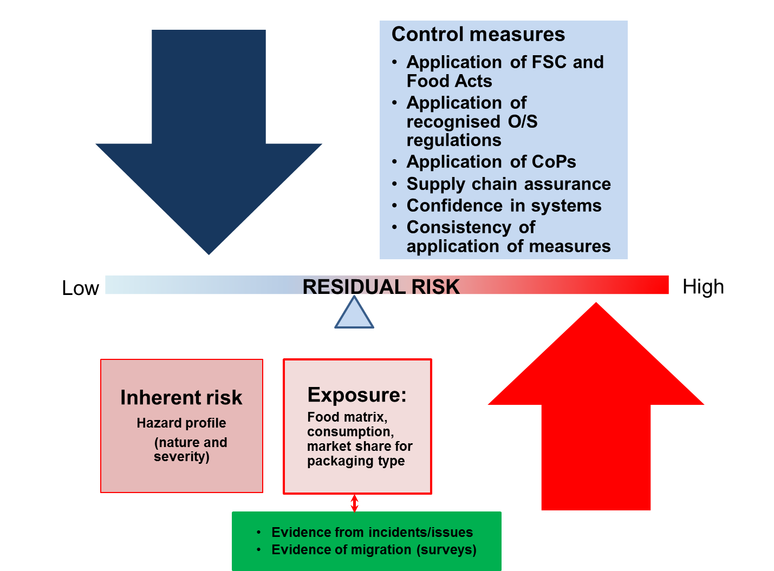

Figure 1: Illustration of factors affecting the residual risk from CMPF.

2.3.3 Risk management options: graduated approach
Developing multiple options for consultation and analysis is an essential step in effective risk management. In order to ascertain the best solution to a problem more than one option needs to be assessed. For example, a maximum level (ML) can be set in the Code when a chemical has been identified that presents a significant risk to public health and safety. However, an ML is only one risk management tool and is usually set in accordance with the following key principles:

- for contaminants that present a significant risk to public health and safety
- for foods that significantly contribute to the dietary exposure of the contaminant
- to ensure that levels are as low as reasonably achievable (ALARA).

Currently, there are three packaging chemicals that meet the above criteria and have MLs in the Code: tin, acrylonitrile, and vinyl chloride (under Schedule 19 of the Code).

FSANZ commenced P1034 in 2014 to consider the most appropriate risk management option(s) needed to control CMPF in Australia and New Zealand, based on the best available science. At that time, FSANZ was aware that large companies in both countries operated with sophisticated programs in place to identify and manage risks from CMPF. These companies use existing regulations or Codes of Practice (COP) that have already been in place in the USA, EU or China for many years. This provides a unique situation in Australia and New Zealand where existing regulations provide a minimum benchmark to control CMPF.
For an overview of those international regulations/COPs refer to the following:
International regulations ​(pdf 146 kb) | (word 68 kb)
Summary of international approaches (pdf 103 kb) | (word 84 kb)
Industry standards & COPs ​(pdf 138 kb) | (word 57 kb)

However, at the 2nd consultation, FSANZ identified risk management options with a view to improving the overall management of risks (if required) compared to the current regulatory approach.

The options that were considered as part of a graduated risk management approach are presented in Figure 2. For FSANZ’s full considerations of the above four options in Figure 2, see pages 11 to 19 of the June 2016 consultation paper.

Figure 2: The graduated risk management approach.

FSANZ’s assessment, based on the information currently available and the public submissions received, was that the graduated approach would be the most effective of the four options available.

The graduated approach would enable low and high risk chemicals to be addressed separately. Low risk chemicals would be managed by using voluntary industry guidelines or greater record keeping and audit requirements under either a guideline and/or amending current requirements in the Code. High risk chemicals will be managed through a regulatory approach (e.g. setting MLs).

Based on the risk assessment work, FSANZ did not identify any chemicals that meet the criteria for a high risk chemical nor any evidence that the Code needs to be strengthened.

2.3.4 Non-regulatory risk management - the food packaging information guide
Stakeholder consultation for P1034 identified gaps in industry awareness of the control measures needed for CMPF, mainly for small-to-medium enterprises (SMEs). Therefore, development of a food packaging information guide was proposed as a
non-regulatory risk management approach. Development of the guide was supported in submissions received to the 2nd Call for Submissions paper. Provision of information is a function of FSANZ under the Food Standards Australia New Zealand Act 1991.

To improve awareness and knowledge about CMPF, FSANZ plans to develop a food packaging information guide to provide a consolidated and comprehensive source of information for industry, address the gaps in awareness and knowledge for SMEs, provide general information on safety issues with CMPF for consumers, and describe the obligations on food businesses (particularly SMEs) to use safe packaging materials.

Modules to be included in the guide are shown in Figure 3. It is envisaged that these will be accessed through the FSANZ website. Development of the information guide will be progressed by FSANZ in a separate project on food packaging, after Proposal P1034 is completed.

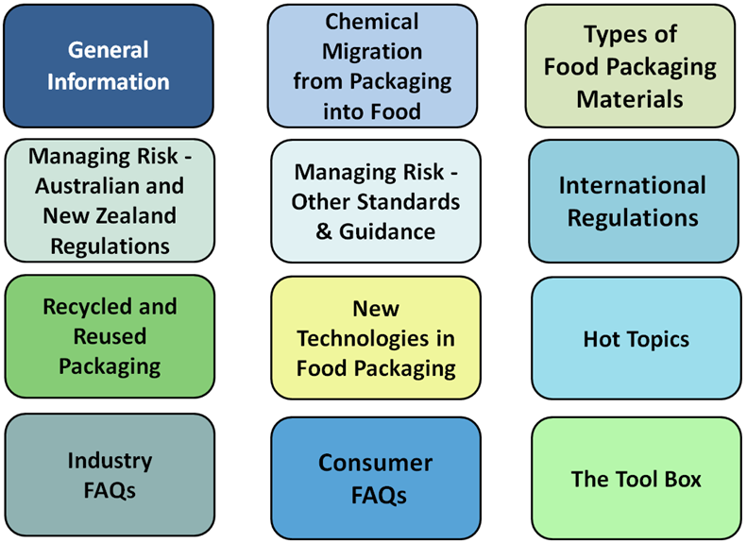

Figure 3 Modules for the food packaging information guide

2.3.5 Conclusion
FSANZ decided to abandon P1034. That is, the development of a food regulatory measure was not warranted. This decision was taken after having regard to the risk management considerations above, the submissions received, feedback received from targeted stakeholder consultation, and risk assessment outcomes, and to the statutory requirements outlined in Section 2.5.

The reasons for this decision are detailed above. In essence, they are as follows:

- The risk assessment concluded that exposures to CMPF are low and unlikely to pose a public health and safety concern.

- Stakeholder consultation confirmed that industry has sufficient control measures in place to control CMPF (which, as mentioned above, presents a low exposure risk).
- Measures other than a food regulatory measure can adequately address residual risk. The FSANZ assessment is that the above-mentioned gaps in industry awareness in relation to CMPF control measures can be addressed through development of a food packaging information guide as opposed to development of a variation to the Code.

The Proposal P1034 did not include modified atmosphere packaging, intelligent packaging and nanomaterials used in packaging. These will be considered in subsequent packaging work by FSANZ.

2.4 Risk communication

2.4.1 Consultation
Consultation is a key part of the regulatory analysis process. FSANZ acknowledges the time taken by individuals and organisations to make submissions on this Proposal.

Two rounds of public consultations were held and submissions are available on the FSANZ website. Issues raised in submissions to the Consultation Paper and Call for Submissions are addressed in section 2.2.5 and Supporting Documents 1 and 2. The Consultation Paper and Call for Submissions generated a high level of public interest and were well received as evidenced by the number and quality of submissions. All comments are valued and contribute to the rigour of our assessment.

Consultation through the PAG was a critical component of the assessment for this proposal. The PAG was established to advise FSANZ on numerous matters related to the assessment, stakeholder concerns, and appropriate risk management options. The PAG composition was diverse with effective trans-Tasman representation of peak bodies, industry members (including SME representation), jurisdictions and a consumer representative. Six meetings of the PAG have been held since its inception in 2014.

2.4.2 Communication strategy
FSANZ developed a communication strategy for P1034. The communication strategy involved establishing consultation mechanisms with industry, jurisdictional and consumer stakeholders, development of website material, and communication through social media. Media releases accompanied consultation documents and were promoted through social media and through Food Standards News.

While abandonment of P1034 closes this stage of FSANZ’s work on food packaging materials, FSANZ will continue to work with key stakeholders to develop the information guide that will assist food businesses to ensure food packaging is safe. FSANZ will also continue to monitor CMPF issues as they emerge and will consider appropriate management options if required. These activities will continue to be communicated through the FSANZ website, publications and social media.

2.5 FSANZ Act assessment requirements

2.5.1 Section 59

2.5.1.1 Cost benefit analysis
FSANZ’s risk assessment has concluded that the human health risk posed by CMPF in Australia and New Zealand is low. As there are no significant public health and safety concerns about current levels of packaging chemicals in food, it is unlikely that further regulatory intervention to manage CMPF would lead to improved health outcomes. As such, any further regulatory intervention would not be expected to realise significant, or possibly any, benefits.
There would, however, be costs associated with introducing regulatory measures. Some examples may include the cost of increasing the traceability of packaging used throughout a product’s development and storage lifecycle, analysis of chemicals in food, and monitoring compliance with the regulatory measures.
The costs that would arise from a food regulatory measure developed or varied as a result of the proposal is highly likely to outweigh the direct and indirect benefits to the community, Government or industry that would arise from the development or variation of the food regulatory measure.
FSANZ may further investigate food contact materials and chemical migration from packaging into food in the future. Costs and benefits arising from any future work associated with CMPF, such as a new food packaging information guide, will be considered as appropriate.

2.5.1.2 Other measures
FSANZ has determined that there are other measures (development of packaging information guide, see Section 2.2.4) that would be more cost-effective than a food regulatory measure or variation as a result of this Proposal.

2.5.1.3 Any relevant New Zealand standards
As explained above, the Code contains packaging related standards that apply in both Australia and New Zealand. There are also several pieces of legislation in New Zealand that relate to food business’ use of packaging: Food Act 2014; Animal Products Act 1999; Food Hygiene Regulations 1974 and Wine Act 2003 (refer to Supporting Document 1 of June 2016 Call for Submissions Paper).

2.5.1.4 Any other relevant matters
Other relevant matters are considered below.

2.5.2 Subsection 18(1)
FSANZ has also considered the three objectives in subsection 18(1) of the FSANZ Act during the assessment.

2.5.2.1 Protection of public health and safety
FSANZ’s assessment, based on the best scientific evidence currently available, is that there is a negligible likelihood of health and safety risks for the Australian and New Zealand populations arising from chemical migration from packaging into food. Therefore imposing regulatory measures such as setting maximum limits for packaging chemicals is not warranted. However, FSANZ has identified suitable non-regulatory measures for this Proposal (see 2.2.4).

2.5.2.2 The provision of adequate information relating to food to enable consumers to make informed choices
There is no evidence that a problem currently exists in terms of provision of information to consumers in order for them to make informed choices in this area. However, the proposed food packaging information guide may include information targeted to consumers to inform them about potential risks of chemical migration from food packaging.

2.5.2.3 The prevention of misleading or deceptive conduct
There is no evidence that a problem exists in terms of misleading or deceptive conduct.

2.5.3 Subsection 18(2) considerations
FSANZ has also had regard to:

- the need for standards to be based on risk analysis using the best available scientific evidence

FSANZ’s risk assessment (see Supporting Document 3) was based on the best scientific evidence currently available.

- the promotion of consistency between domestic and international food standards

We examined international standards for managing CPMF (see June 2016 Call for Submissions paper) and some submissions noted that adoption of other countries regulations could provide industry-wide conformity and added health and safety benefits.

However, based on the risk assessment work, there was insufficient evidence indicating that the Code needs to be strengthened through adoption of other countries regulations. FSANZ has also concluded that promotion of consistency between domestic and international food standards can be achieved through provision of additional information on international regulatory systems through the food packaging information guide.

Therefore, no change is proposed to the relevant standards.

- the desirability of an efficient and internationally competitive food industry

This decision taken is commensurate with the assessed risk and does not impose any unnecessary additional economic burden on the food industry.

- the promotion of fair trading in food

There is no evidence that a problem exists in this regard.

- any written policy guidelines formulated by the Forum on Food Regulation

There are no relevant policy guidelines.

3 Rights of review
Subparagraph 143(1)(b)(ii) of the FSANZ Act allows a person whose interests are affected by FSANZ’s decision to abandon this Proposal to apply to the Administrative Appeals Tribunal for a review of that decision.

This right of review is subject to the Administrative Appeals Tribunal Act 1975 (the AAT Act). In other words, the AAT Act sets out the specific requirements relating to applications for review, for example, how such applications are made and processed; as well as procedures relating to the review itself.

Attachment 1

Chronological milestones of FSANZ work on food packaging chemicals
Milestone | Main Outcome or Description | Date
Update to FSANZ Board | Progress on the study of the merits of regulating packaging in the Code was presented. Further investigation was supported. | 2007
Preliminary work commenced | Objective was to review the adequacy of the current regulatory framework for food contact packaging materials. The work was prompted by ongoing concern from stakeholders about the migration of certain packaging materials into foods and subsequent potential public health effects. | 2007
Background research | Reviews of international approaches and industry practices in managing risks from chemicals in food packaging. | 2008-2009
Analytical surveys completed | BPA: Results showed only a limited number of samples had detectable levels of BPA. Dietary exposure to BPA for the Australian population was low for all age groups. See: FSANZ Survey of Bisphenol A in Australian Foods  Food Contact Packaging Materials: Results showed no detections of phthalates, semicarbazide, perfluorinated compounds, acrylonitrile or vinyl chloride in any of the foods analysed; low levels of ESBO in a small number of samples. Dietary exposure to ESBO estimated to be very low. See: Survey of Chemical Migration from Food Contact Packaging Materials in Australian Food | 2010
Industry Advisory Group (IAG) established | Convened to inform the FSANZ review of food packaging regulations. Membership comprised representatives from the food and packaging industry. Three meetings were held. Group disbanded in 2014. | 2011
Industry surveys | Food packaging manufacturers and the food industry were surveyed through two online surveys to establish current industry practices in relation to food contact materials. Results were published in 2014 1st Call for Submissions. | 2012-2013
Issues paper to FSANZ Board | Issues paper summarising packaging work to date (including packaging survey responses) was presented. Preparation of the proposal was supported. | Dec 2013
Proposal P1034 commenced | P1034 aim is to assess the public health and safety risks of chemical migration from packaging into food (CMPF) and to identify and manage any risks. | Jun 2014
Packaging Advisory Group (PAG) established – PAG#1 | Convened to provide advice and information for issues covered in P1034. Membership comprised of representatives from Australian and New Zealand industry, government, and consumer groups. | Jun 2014
PAG meeting #2 | Input sought on the draft 1st Call for Submissions (issued in November 2014) | Sep 2014
Risk assessment | Risk profile of food packaging chemicals using TTC approach to assess over 1300 food contact substances. | 2014
Consultation Paper issued | Risk assessment work reported and information requested on the food packaging market, risk management practices used by manufacturers, and gaps in current regulatory/non-regulatory approaches to ensure safe food packaging. See: P1034 – Chemical Migration from Packaging into Food | Nov 2014
PAG meeting #3 | FSANZ sought input on issues identified in submissions to the 1st CFS. | Mar 2015
1st Consultation Paper feedback | Wide stakeholder consultation to obtain views on 1st Call for Submissions. Parties consulted through teleconference, face-to-face meetings, and industry site visits and included government (NZ MPI, Commonwealth departments, states, territories and local city councils representatives), industry representatives, and consumer groups. This included focussed face to face stakeholder consultations in Melbourne, Sydney and in New Zealand | 2015
Update to FSANZ Board | Presented outcomes of the 1st Call for Submissions and an outline of work in progress. | Sep 2015
Analytical survey (NZ MPI) | Commenced analytical surveys to obtain occurrence data for phthalates, photo initiators and printing inks in takeaway and packaged foods. | 2015-2016
FSANZ-ISFR Packaging workshop | Workshop held with Implementation Subcommittee for Food Regulation (ISFR) representatives to share progress on P1034 and obtain input on proposed risk management options. | Dec 2015
PAG Meeting #4 | FSANZ sought input on the CMPF risk profile using the TTC approach and on proposed risk management options. The analysis of information provided by industry on CMPF control measures was presented. | Jan 2016
Analytical survey completed | Publication of a screening study which investigated levels of 30 food packaging chemicals in the Australian food supply. See: 24th Australian Total Diet Study – Phase 2 | Jan 2016
Dietary Exposure Assessment | Dietary exposure assessment conducted for phthalates in the Australian population | Dec 2016
1st Call for Submissions issued | Public consultation paper that reported assessment results and proposed risk management options. Most submitters supported the graduated risk management approach and the proposed development of packaging information guide. | Jun 2016
Analytical survey (FSANZ) | Sampling and lab analysis of phthalates in foods - follow-up survey to 24th ATDS Phase II | 2016-2017
Analytical survey (FSANZ) | Sampling and lab analysis of mineral oil hydrocarbons (MOH) in paperboard packaging and foods | 2016-2017
PAG meeting #5 | Results from analytical surveys and exposure assessments were reported; input sought on the draft food packaging information guide and direction for completion of the proposal. | Jun 2017
ISFR consultation | FSANZ consulted with ISFR on status of P1034 and plans for a food packaging information guide to be developed. | Aug 2017
Update to FSANZ Board | Presented summary of P1034 work and plans to finalise the proposal through abandonment | Sep 2017
Abbreviations: NZ MPI (New Zealand Ministry of Primary Industry); BPA (bisphenol A); MOH (mineral oil hydrocarbon); ESBO (epoxidized soybean oil); TTC (threshold of toxicological concern); ATDS (Australian Total Diet Study); ISFR (Implementation Subcommittee for Food Regulation).

Refer to Submissions to the 1st Call for Submission paper, November 2014:
http://www.foodstandards.gov.au/code/proposals/Pages/P1034ChemicalMigrationfromPackagingintoFood.aspx
The TDI is an estimate of the amount of a substance in food that can be ingested daily over a lifetime without appreciable health risk.
http://www.eupia.org/index.php?id=31&tx_edm_pi1%5BshowUid%5D=21&cHash=6495d86ce2d7a8022a1802b356c4fd2a
http://www.foodstandards.gov.au/code/proposals/Documents/P1034 Packaging 1CFS.pdf
http://www.foodstandards.gov.au/code/proposals/Documents/P1034 Packaging 1CFS.pdf
http://www.foodstandards.gov.au/code/proposals/Pages/P1034ChemicalMigrationfromPackagingintoFood.aspx
Preliminary work was preceded by proposal P205 Articles & Materials In Contact With Food which was undertaken by ANZFA as part of the process of the review of the Food Standards Code in 1999-2000. This work is not included in the above chronology.

